Capstone Project – The Battle of Neighborhoods

Final Report

Version: 1.0
February 2020

Johnnie Ng

Table of Contents
1 Background 2
2 Problem 2
3 Interest 2
4 Data acquistion and cleaning 2
5 Methodology 3
6 Results 7
7 Discussion 8
8 Conclusion 8

- Background
Toronto is the provincial capital of Ontario and the most populous city in Canada, with a population of 2,954,024 as of July 2018. Toronto is an international centre of business, finance, arts, and culture, and is recognized as one of the most multicultural and cosmopolitan cities in the world. People have travelled through and inhabited the Toronto area for more than 10,000 years. The diverse population of Toronto reflects its current and historical role as an important destination for immigrants to Canada. For Chinese people who are new to Toronto, how do they know what the best Chinese restaurants are worth going to and where they are?

- Problem
This project aims to create a simple Chinese Restaurants Guide based on Foursquare Rating, restaurant category and geographic location data for restaurants in Toronto. Finally, these restaurants will be clustered based on their similarities.

- Interest
Obviously, Chinese people who will consider visiting Toronto will be interested to explore Chinese restaurants to get something to eat. Others who want to try the Chinese food may also be interested.

- Data acquistion and cleaning
- Scrape the following Wikipedia page

https://en.wikipedia.org/wiki/List_of_postal_codes_of_Canada:_M

in order to obtain the data that is in the table of postal codes and to transform the data into a pandas dataframe.

- Get geolocator latitude and longitude coordinates for Toronto.

- Use Foursquare API to get a list of venues in Toronto.

- Use Foursquare API to get restaurant name, ID, location, category and rating.

- Methodology
- Use Beautiful Soup library in python to scrape the Wikipedia page to extract the data in the tabular format as shown in the website.

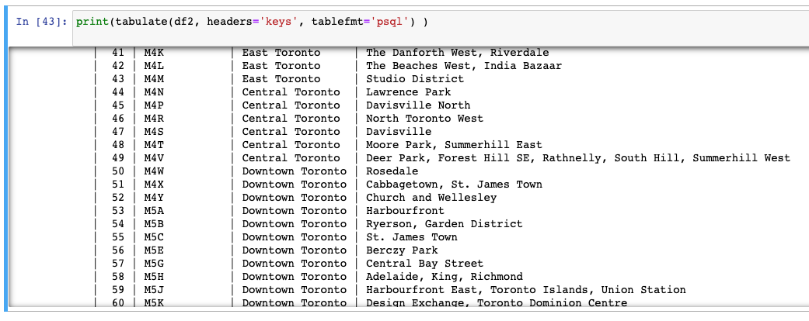

- Use the csv file to create the dataframe with Latitude and Longitude and Merge two data sets on the Postal Code to form a new data set for visualization.

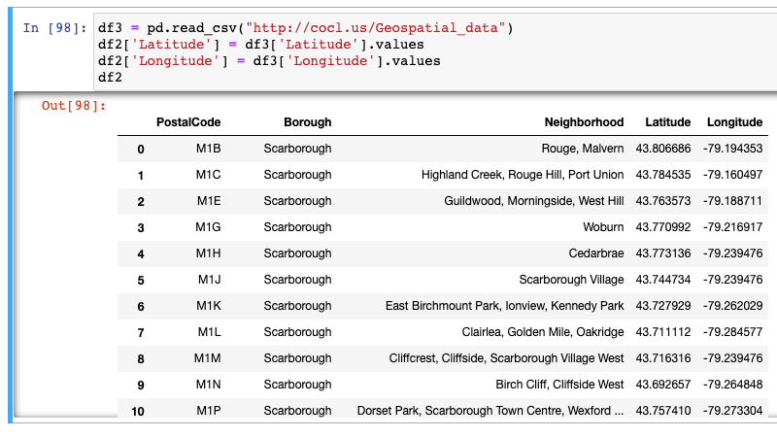
- Use geopy library to get the latitude and longitude values of Toronto and create a map of Toronto with neighborhoods superimposed on top.

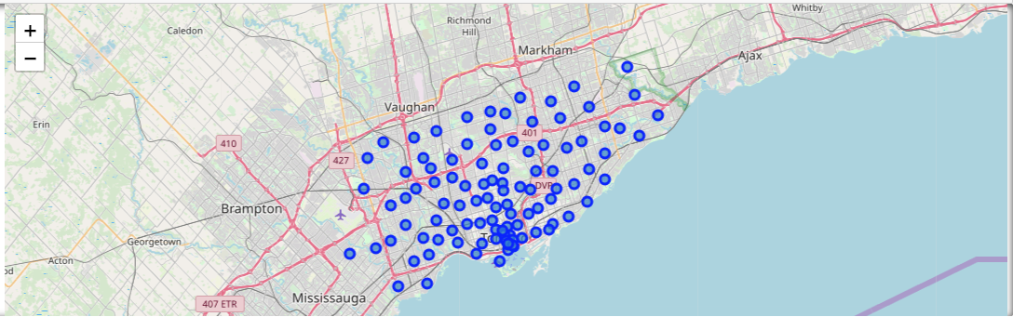

- Work with only boroughs that contain the word Toronto.

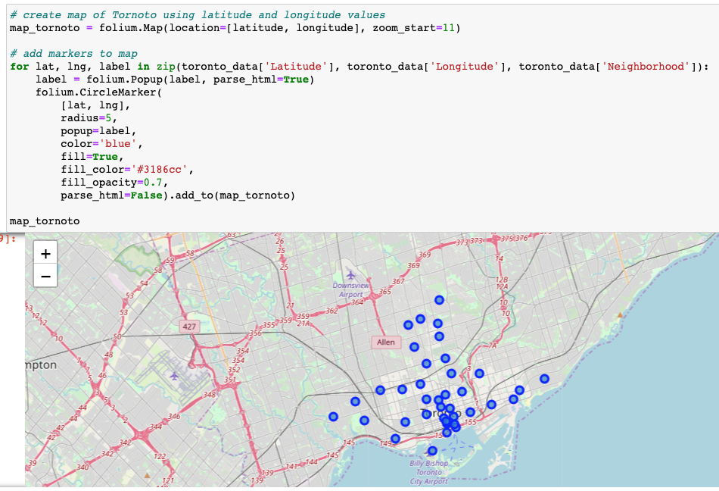

- Use Foursquare API to explore all Chinese Restaurants in Toronto with radius = 500.

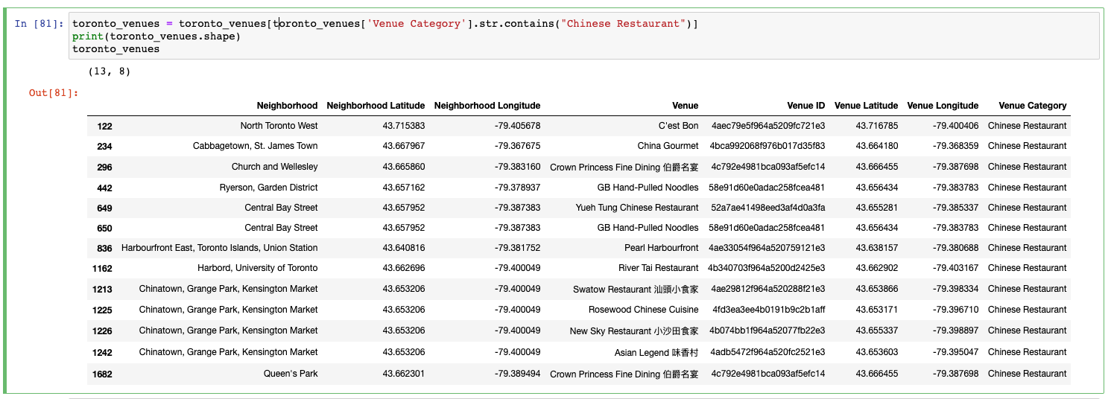

- Use Foursquare API to get rating of Chinese Restaurants based on venue id.

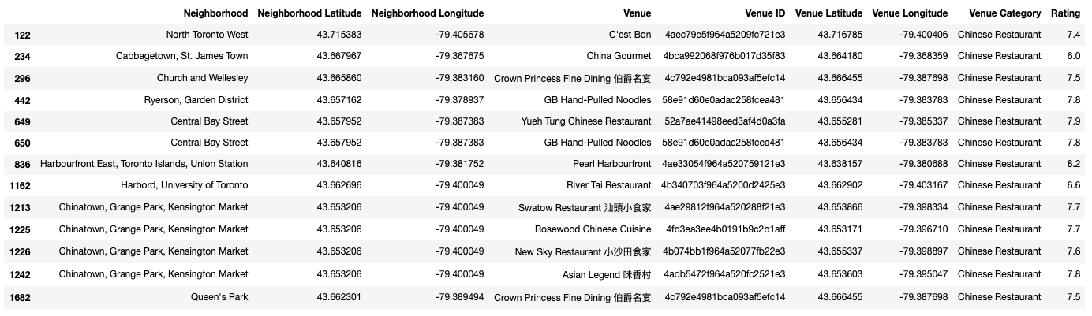

- Use k-means clustering algorithm that groups Chinese Restaurants into 4 clusters.

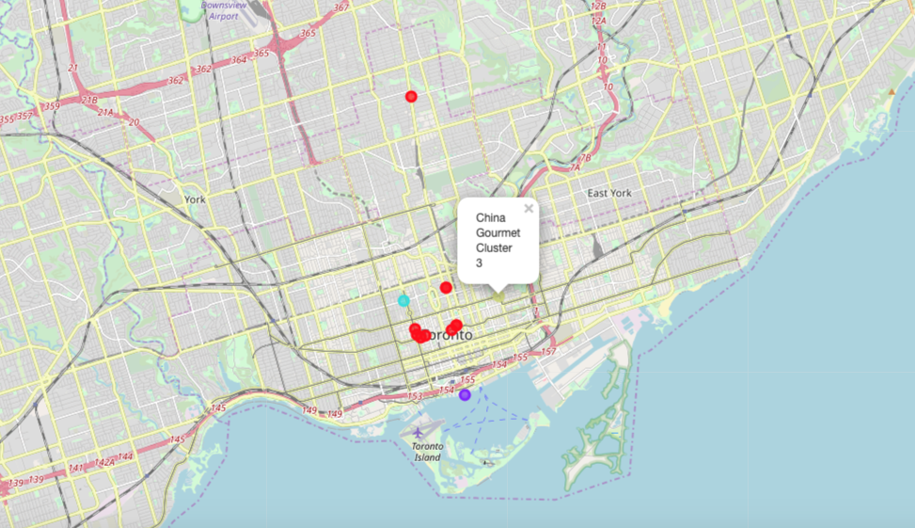

- Results
- Cluster 1

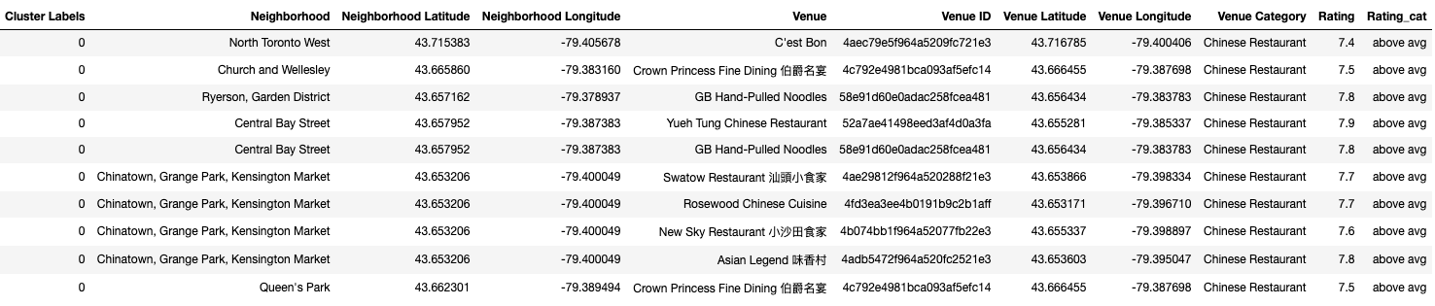

- Cluster 2

- Cluster 3

- Cluster 4

- Discussion
The aim of this project is to help people who want to visit Toronto and choose the Chinese restaurants based on the rating recommended in Foursquare. For example, if a person is looking for a Chinese restaurant with good rating, we can see that Cluster 1 and 2 have rating above 7.4. If a person is looking for a Chinese restaurant with the highest rating, the Chinese restaurant in the second cluster is suitable. For budget consideration, Chinese restaurants in Cluster 3 and 4 are more suitable and the rating is around 6.0. The preference of Chinese restaurants may vary from person to person, they can select a restaurant based on their own tastes and the proximity.

- Conclusion
This project helps a person get a better understanding of a specific type of restaurant in one area. It is always helpful to make use of technology to stay one step ahead, i.e. finding out more about rating before choosing the place to eat. We have just taken rating as a primary concern to shortlist the best Chinese restaurant in Toronto. The future of this project includes taking other factors such as pricing and number of likes into consideration to filter restaurants based on a predefined budget and other comments.

- END -

